PsychMonkey7 Software Requirements 20150503

Introduction
  - Purpose
Initial requirements and constraints for PsychMonkey7, an application for psychiatric practitioners to use in capturing the patient encounter. This is an interim step in a much longer project leading to development of a fully functional web application; PsychMonkey7’s purpose is to demonstrate only very basic functionalities.

  - Scope of Project
The scope of this part of the project is creation of a cognitively based web application demonstrating use of a knowledge base, rules, processes, and persistence in a database. PsychMonkey7 should also demonstrate use of standards for information models, data interchange, web services and terminologies.

  - Glossary
Condition
Knowledge service
Observation
Process service
Psychiatric pracitioner—psychiatrist or psychiatric nurse practitioner seeing psychiatric patients in an outpatient clinic. “Psychiatrist” will also be used to mean psychiatric practitioner.
PsychMonkey—refers to the eventual fully built web application. PsychMonkey7 refers to the current, partial implementation.
Rule service

  - References

  - Overview of Document
In subsequent sections, the overall description, constraints, and functional requirements of this system will be outlined. Within section two of the document, the development team will address the functionality and usage of the system in a deployed environment. The third section will address specific requirements; including technical requirements of this software. This section will provide aid to developers of this scheduling application.

- Overall Description
  - System environment
The psychiatric practitioner will be expected to use this web application in a browser on a tablet type computer, in the practitioner’s office. The tablet computer will be wirelessly networked to a server within the office.

  - Functional requirements
    - Use case
PsychMonkey7 allows a psychiatric practitioner to login and retrieves patient identification and demographic data from the database. It then allows the psychiatric practitioner to capture the patient encounter. While asking the patient questions the psychiatrist clicks on index items to access lists of possible observations, and instantiates observations by dragging and dropping them from a possible observations column to an observations column. At each observation drag/drop, PsychMonkey7 queries a knowledge service, which returns conditions which are suggested by the newly instantiated observation. These conditions are displayed as suggestions in the Problems column. The psychiatrist may accept any of these system suggestions by single clicking on them, in which case they then show as accepted. Acceptance of a condition in the Problems column results in a query being sent to the knowledge base asking for diagnoses that are suggested by the accepted Condition. Any diagnoses returned then populate the Diagnosis Column.

    - Process diagram
The user psychiatrist may perform any of 12 different actions at any stage. In PsychMonkey7, only 5 of these will be implemented. Each action taken will result in a visible change to the state of the browser screen. Next, the web app’s information model will be changed. In three of the cases shown below, a service call will be sent to the knowledge base. If a response is received, that response is used to update the web app’s information model again. The state of the information model is then propogated out to the client’s browser screen.
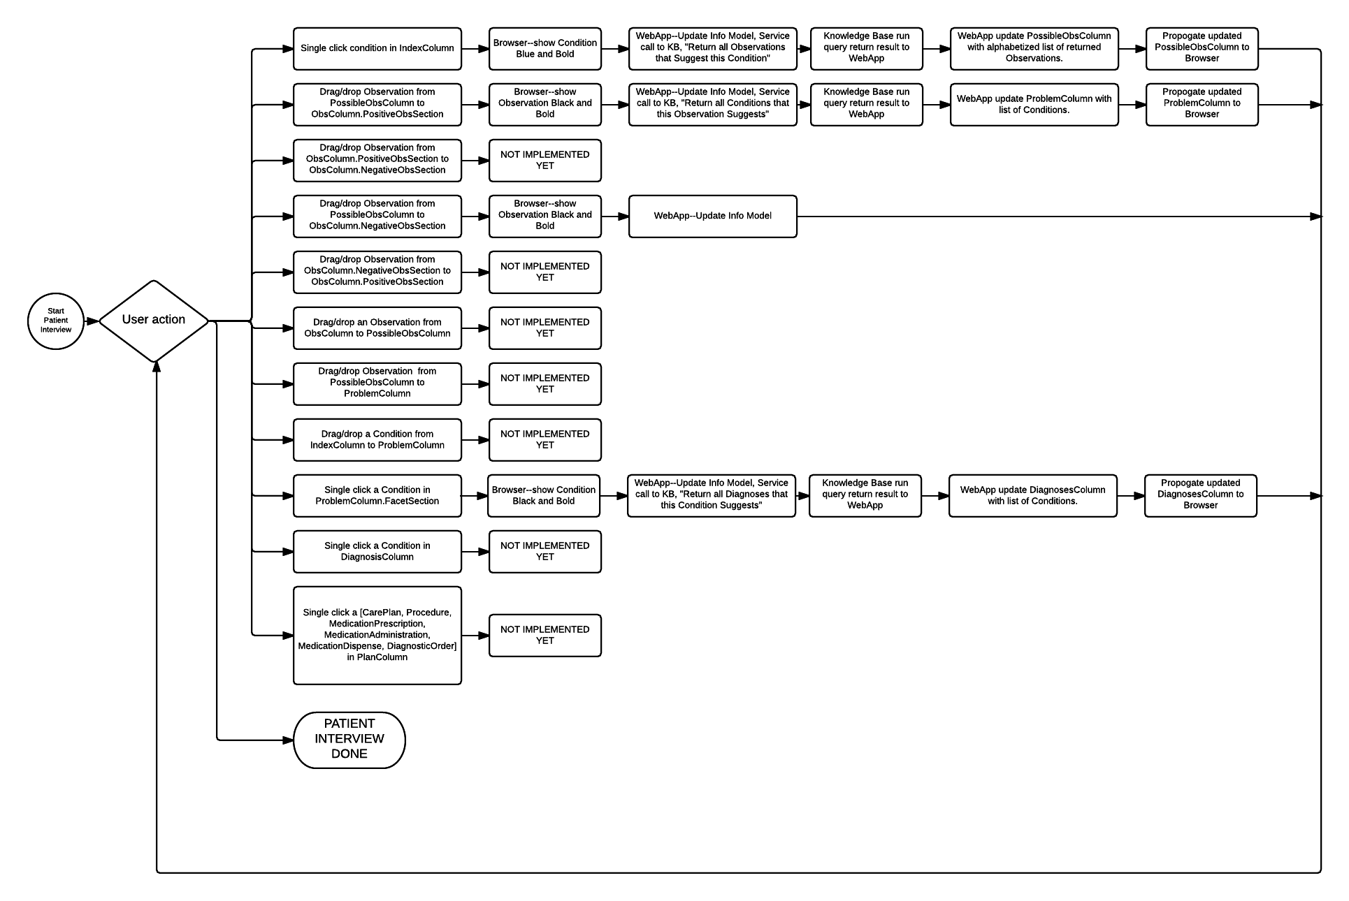
  - User characteristics
The psychiatrist will be familiar with tablet computers and be able to turn it on and start the application. He will know how to use a stylus to drag/drop and single click items. No other knowledge is expected.

  - Nonfunctional requirements
PsychMonkey will eventually be hosted on an office server connected wirelessly to psychiatrists’ tablet computers. This will have to be done in a fully secure environment. The current iteration, PsychMonkey7, will simply be hosted on a web server of convenience for demonstration purposes, and will not deal with actual patient data. PsychMonkey7 will be expected to operate at “blink speed” from the standpoint of the psychiatrist; from browser drag/drop to browser display of entities returned from the knowledge base should take less than 0.2 seconds.

- Specific technical requirements
  - External interfaces
This web application will be a web service and a web client itself, and will reside within a Tomcat server environment on the office server. The knowledge service, rules service and process service will likewise be hosted on the office server. The web application will generate REST function calls to the other services. Client browsers will connect via http protocols to office PsychMonkey server. A client-server orchestration pattern will be followed for PsychMonkey7, in that the central web app will receive input from the client browser, generate calls to other services, process the information received and return it to the client browser.

  - Detail of functional requirements
PsychMonkey7 is being developed using Java and Maven. The database will be in MySQL.
This diagram shows the PsychMonkey7 web app’s information model. PsychMonkey7’s user interface as shown in the psychiatrist’s browser essentially duplicates this diagram.
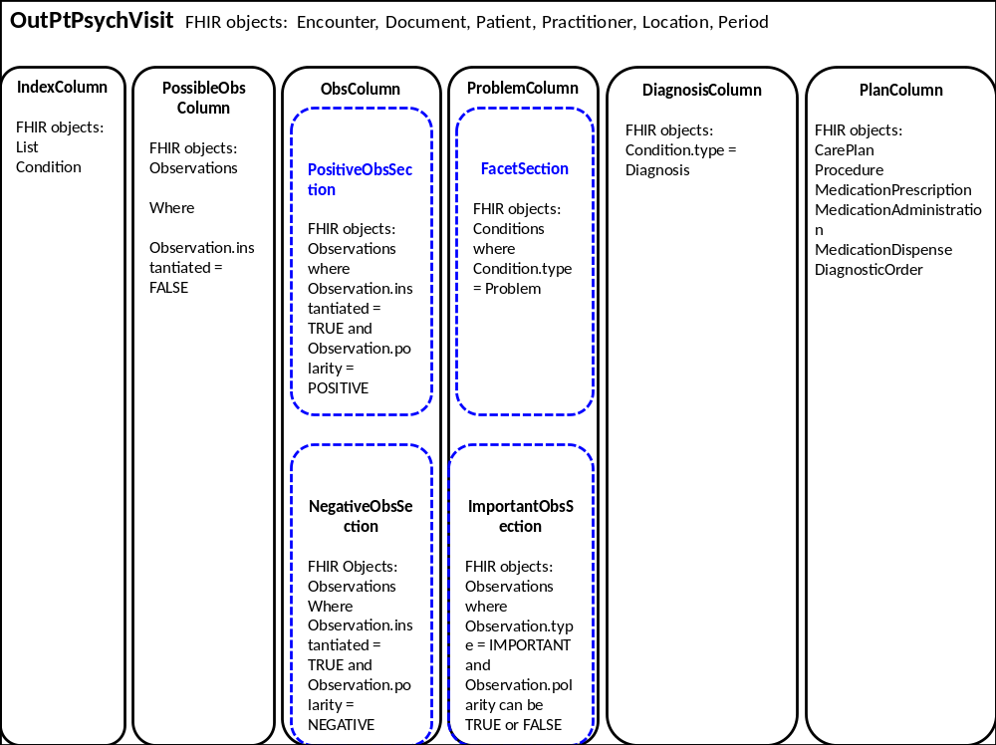

  - Functions
Trigger: | Single click item in IndexColumn
Goal In Context: | Psychiatrist wishes to access Observations other than those currently displayed.
Scope: | PsychMonkey7
Pre-Condition: | An OutPtPsychVisit has been initiated.
Success End Condition: | Single clicked item in IndexColumn displayed blue and bold font. A new list of Possible Observations is displayed in the PossibleObsColumn.
Failed End Condition: | Single clicked item not displayed blue/bold. No new list of Possible Observations is displayed in PossibleObsColumn
Trigger: | Drag/drop Observation from PossibleObsColumn to ObsColumn.PositiveObsSection
Goal In Context: | Psychiatrist wishes instantiate an Observation on the current patient as being present.
Scope: | PsychMonkey7
Pre-Condition: | An OutPtPsychVisit has been initiated and desired Observation is displayed in the PossibleObsColumn.
Success End Condition: | Observation shows in black bold font in the ObsColumn.PositiveObsSection. Conditions (if any) Suggested by this Observation now are displayed in the ProblemsColumn in gray, nonbold font indicating such Conditions are system suggested, not user confirmed.
Trigger: | Drag/drop Observation from PossibleObsColumn to ObsColumn.NegativeObsSection
Goal In Context: | Psychiatrist wishes instantiate an Observation on the current patient as being absent.
Scope: | PsychMonkey7
Pre-Condition: | An OutPtPsychVisit has been initiated and desired Observation is displayed in the PossibleObsColumn.
Success End Condition: | Observation is prefixed by “NOT ” shows in black bold font in the ObsColumn.NegativeObsSection. Conditions (if any) Suggested by this negative Observation now are displayed in the ProblemsColumn in gray, nonbold font indicating such Conditions are system suggested, not user confirmed.
Trigger: | Single click a Condition in the ProblemColumn.FacetSection
Goal In Context: | Psychiatrist wishes to confirm or accept a system-suggested Condition as being present, OR to unconfirm a previously confirmed Condition.
Scope: | PsychMonkey7
Pre-Condition: | An OutPtPsychVisit has been initiated and one or more Conditions are present in the ProblemColumn.FacetSection.
Success End Condition: | Unconfirmed Condition (gray/nonbold) has been toggled to confirmed (black/bold). OR Confirmed (black/bold) Condition has been toggled to unconfirmed (gray/nonbold). The change has been sent to the web app information model. A query has been generated and sent to the Knowledge server. The results have updated the web app’s information model and been propagated to the client’s browser.

  - User input and validation
All Observations and Conditions upon which the user may act are valid Concepts in the underlying knowledge base, and connected to SNOMED by their unique identifier code. If the psychiatrist attempts to click on, or drag/drop any entity where it’s not allowed, nothing happens, and and no event is generated. This design does not allow invalid input.

  - Security
As noted above, PsychMonkey7 uses no real patient data, it is a preliminary step toward an eventual full-featured clinical application. Psychiatrist login and other security features may be implemented as stubs.

  - sldkfjl

